**Renko and MACD Trading Strategy with MetaTrader 5 (MT5)**

**Overview**

This script implements an automated trading strategy using the Renko charting technique and the Moving Average Convergence Divergence (MACD) indicator. The strategy runs on the MetaTrader 5 (MT5) trading platform. It monitors multiple currency pairs, evaluates trading signals based on Renko bricks and MACD indicators, and places trades automatically.

The script includes functions for technical analysis, data handling, and trade execution. Below is a detailed explanation of the code, its components, and the concepts used.

**How to Use the Script**

1. **Prerequisites:**
   * Install MetaTrader 5 (MT5) terminal and set it up with a trading account.
   * Install the required Python libraries:
   * pip install MetaTrader5 pandas numpy stocktrends
   * Save your MT5 account credentials in a key.txt file in the format:
   * <account_number>
   * <password>
   * <server>
   * Update the path variable in the script to the location of the MT5 terminal on your system.
2. **Execution:**
   * Run the script, and it will automatically analyze the specified currency pairs (EURUSD, GBPUSD, etc.), generate buy/sell signals, and execute trades based on the Renko and MACD strategy.

**Key Concepts and Indicators**

**Renko Charts**

* **Definition:** Renko charts are a type of charting technique that filters out market noise by focusing only on price movements, ignoring time and volume by eliminating the candlesticks wicks from it.
* **Construction:**
  + Bricks are created when the price moves by a predefined amount (brick size).
  + Uptrend bricks are colored green; downtrend bricks are colored red.
* **Usage:** Renko charts help identify trends and reversals clearly.
* **Example:** Below is the example of the chart with renko bricks.

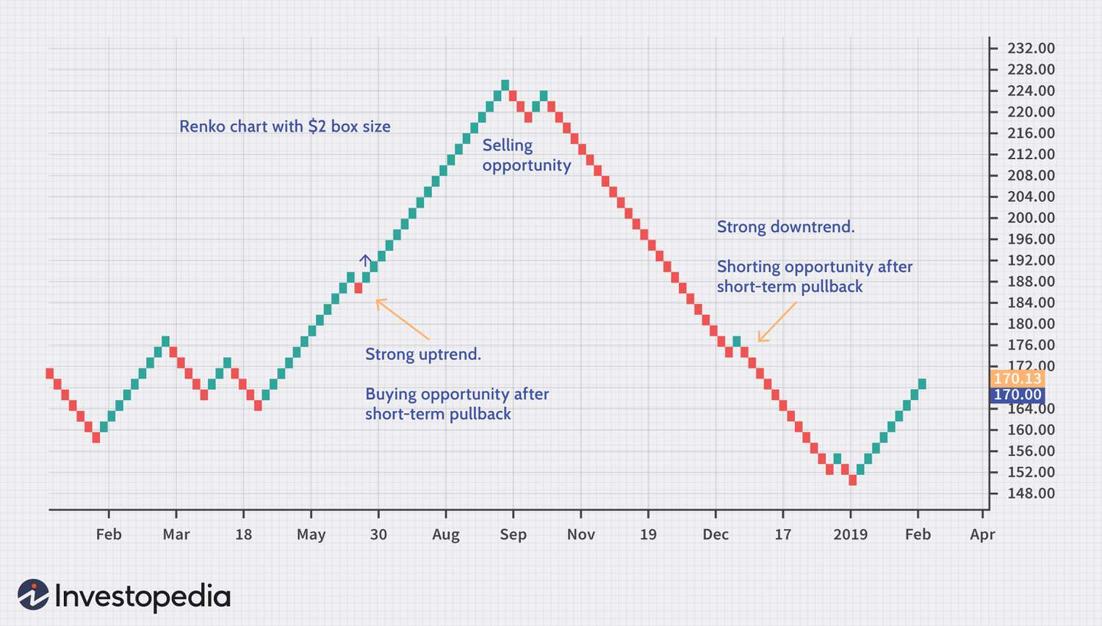

**MACD (Moving Average Convergence Divergence)**

* **Definition:** MACD is a trend-following momentum indicator.
* **Components:**
  + **MACD Line:** Difference between the 12-period and 26-period Exponential Moving Averages (EMA).
  + **Signal Line:** 9-period EMA of the MACD line.
  + **Histogram:** Visual representation of the difference between the MACD and Signal lines.
* **Usage:**
  + A buy signal occurs when the MACD line crosses above the Signal line.
  + A sell signal occurs when the MACD line crosses below the Signal line.
* **Picture example:** 
  + Below is the example in which macd crossovers are shown and when a signal is generated .

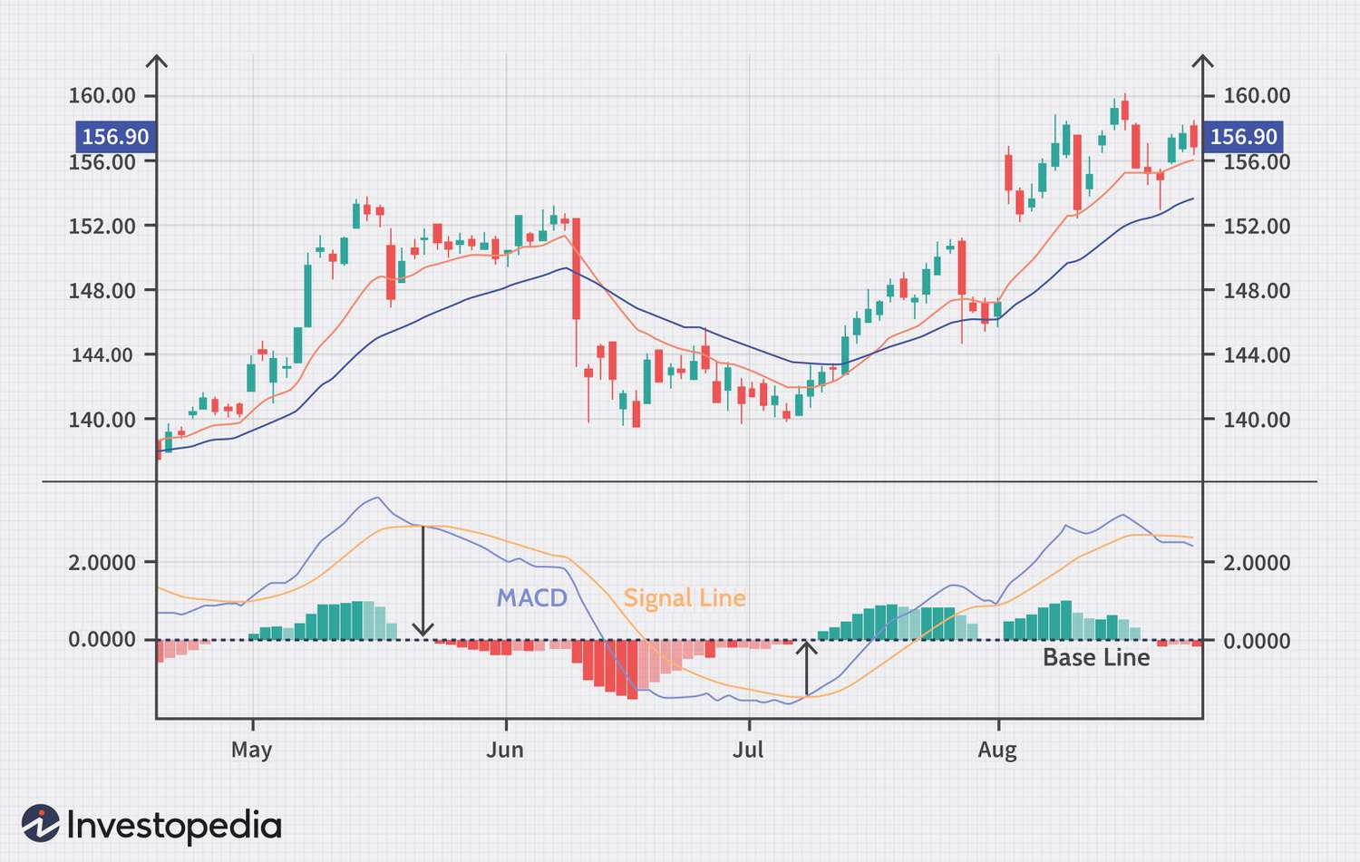

**ATR (Average True Range)**

* **Definition:** ATR measures market volatility.
* **Usage:** ATR is used to determine the brick size for Renko charts.

Before diving into the script details, it might help to briefly recap the purpose of the indicators and their integration into the strategy.

**Script Details**

**Initialization** 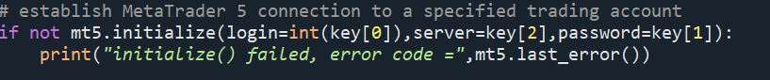

* Connects to the MT5 terminal using credentials from the key.txt file.

**Technical Indicator Functions**

1. **MACD Calculation:**

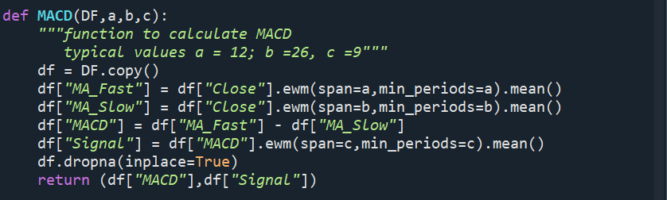

* Calculates the MACD and Signal lines using exponential moving averages.

1. **ATR Calculation:**

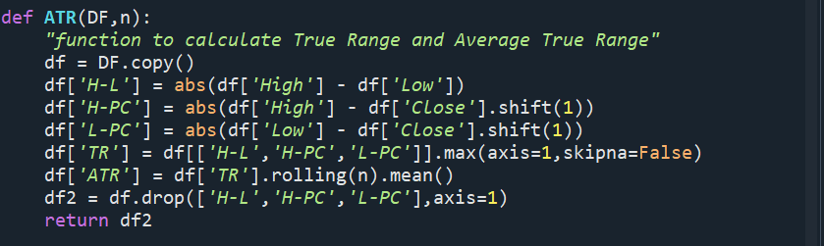

* Used to determine the Renko brick size.

1. **Renko Transformation:**

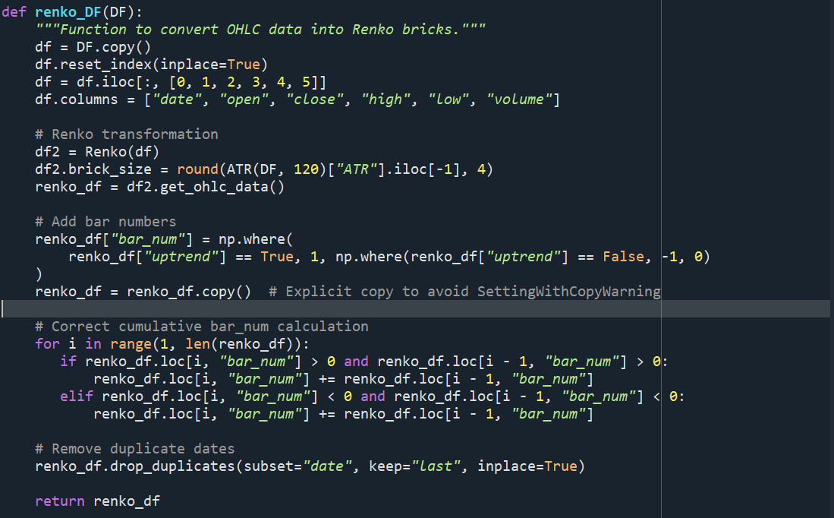

* Converts OHLC data into Renko bricks using the ATR as the brick size.

1. **Renko Merge Function:**

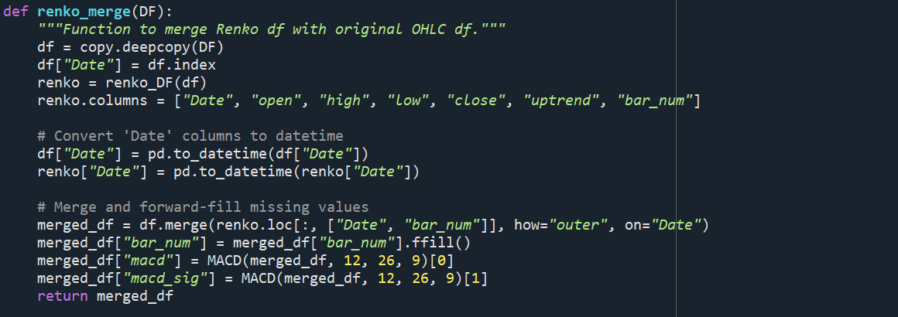

* **Merges Renko bricks with the original OHLC data for further analysis.**

1. **Get Position DataFrame:**

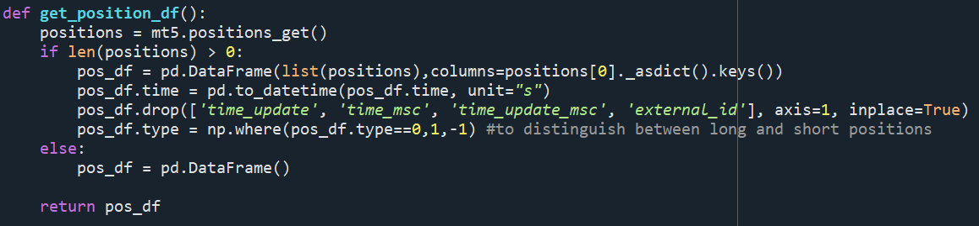

* **Fetches the current open positions and returns them as a DataFrame.**

1. **Get 5-Minute Candles:**

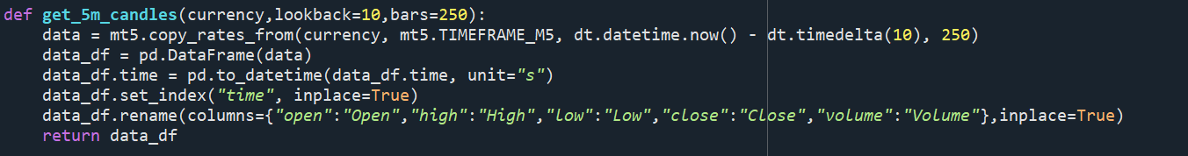

* **Retrieves 5-minute candlestick data for the specified symbol.**

**Trade Signal Generation:**

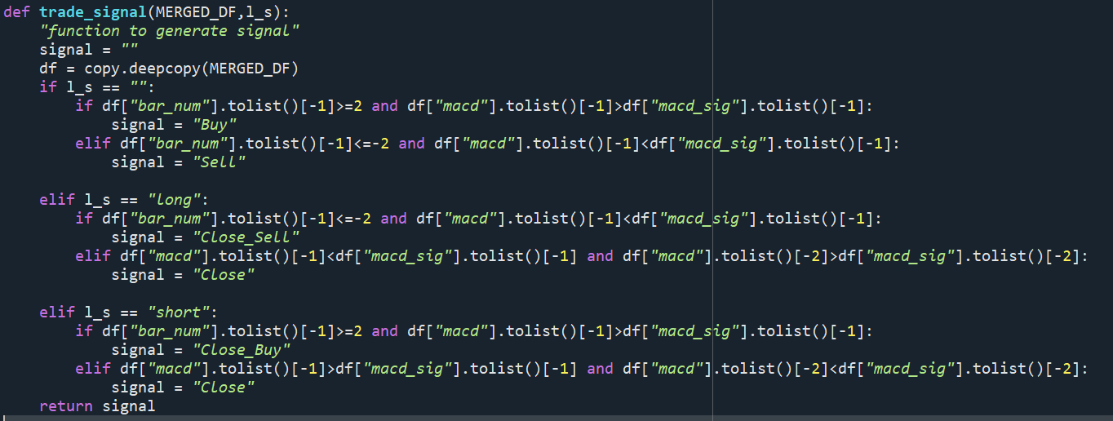

**Generates buy/sell signals based on Renko bar numbers and MACD crossovers.**

**Trade Execution**

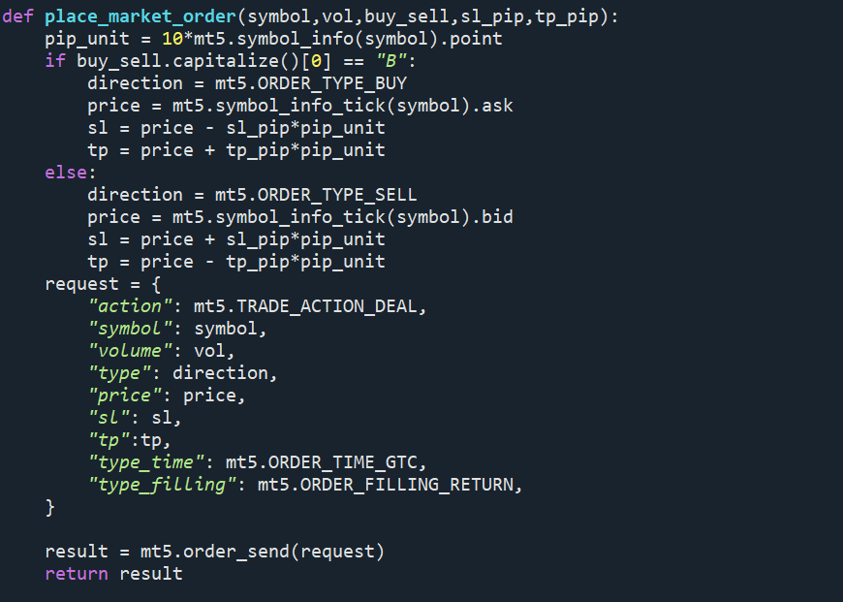

* **Executes market orders with specified stop-loss and take-profit levels.**

**Main Function and Execution**

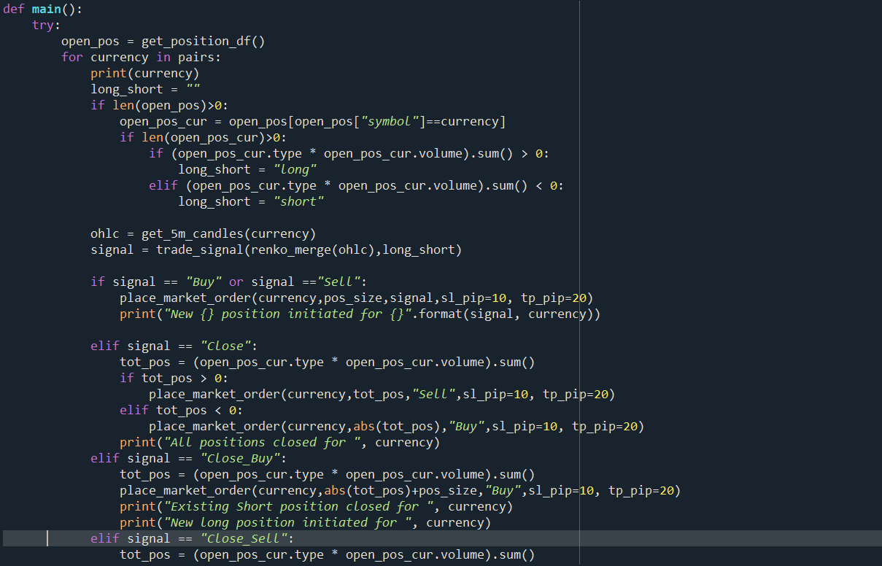

* **Continuously executes the strategy every 5 minutes for 1 hour.**

**Additional Notes**

* **Risk Management:**
  + **The pos_size variable controls the maximum capital allocated per trade.**
  + **Stop-loss (sl_pip) and take-profit (tp_pip) are used to manage risk.**
* **Customization:**
  + **You can modify the currency pairs, indicator parameters, and timeframes as needed.**

**References**

* [**MetaTrader 5 Python API Documentation**](https://www.mql5.com/en/docs/integration/python_metatrader5)
* [**Renko Chart Explanation**](https://www.investopedia.com/terms/r/renkochart.asp)
* [**MACD Indicator Guide**](https://www.investopedia.com/terms/m/macd.asp)